PRACTICAL 11
Aim: Create XMS schema file for student information and create a valid well-formed XML document to store student information against this schema file.

Stud.xsd
<?xml version="1.0"?>
<xs:schema xmlns:xs="http://www.w3.org/2001/XMLSchema"
targetNamespace="http://www.ddd.com"
xmlns="http://www.ddd.com"
elementFormDefault="qualified">
<xs:element name="student" >
<xs:complexType>
<xs:sequence>
<xs:element name="rollno" type="xs:integer"/>
<xs:element name="name" type="xs:string"/>
<xs:element name="marks" type="xs:integer"/>
</xs:sequence>
</xs:complexType>
</xs:element>
</xs:schema>

Student.xml
<?xml version="1.0" encoding="UTF-8"?>
<student xmlns:xsi='http://www.w3.org/2001/XMLSchema-instance'
xmlns='http://www.ddd.com'
xsi:schemaLocation='http://www.ddd.com stud.xsd'>
<rollno>37</rollno>
<name>ABC</name>
<marks>78</marks>
</student>

OUTPUT:

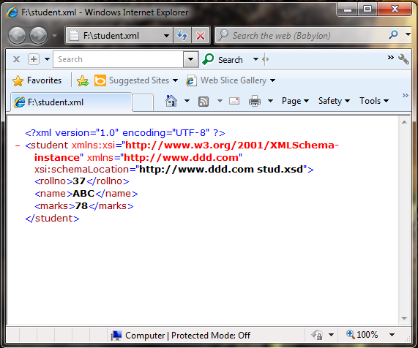

OUTPUT:

